SUPERSTORE SALES DATA IMPORT, POWER QUERY AND DATA CLEANING USING POWER BI

Name: Varnikasri G
Roll No: E25DA051
Department: B.sc DS & AI

1. Introduction
- Power BI is a Business Intelligence and Data Visualization tool.
- It is used to:
  - Import data
  - Clean data
  - Transform data
  - Analyze data
  - Create visualizations
- The Superstore Sales dataset was used for this project.
- The dataset was imported into Power BI.
- Power Query Editor was used for data cleaning and transformation.
- The main activities performed were:
  - Checking the dataset
  - Changing data types
  - Cleaning text fields
  - Adding a new column
  - Extracting Year from the date field
Figure 1: Superstore Sales Datase
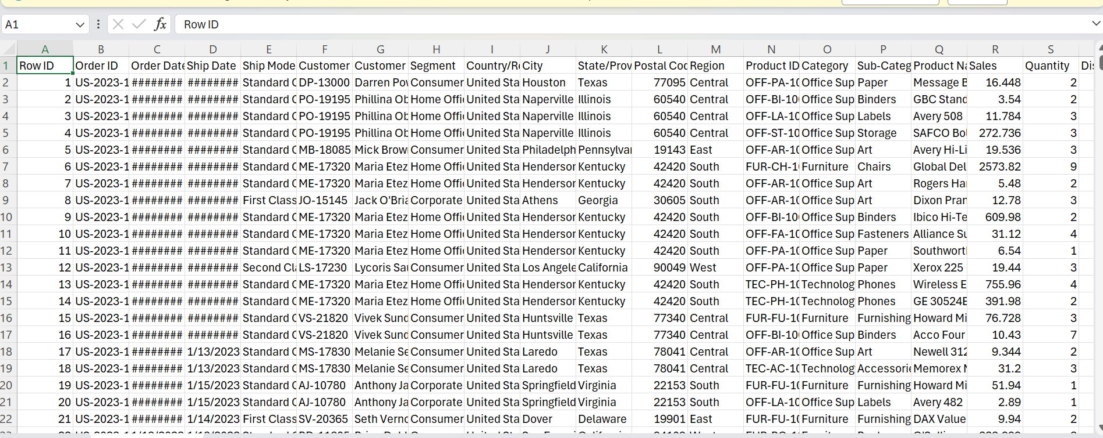

2. Dataset Import
- The Superstore Sales dataset was available in CSV format.
- The CSV file was imported into Power BI Desktop.
- During the import process:
  - File Origin was selected as Unicode (UTF-8).
  - Delimiter was selected as Comma.
- The data preview was checked.
- The columns and values were verified.
- After verification, Transform Data was selected.
- The dataset was opened in Power Query Editor for cleaning.
Figure 2: Importing the Superstore Sales Dataset
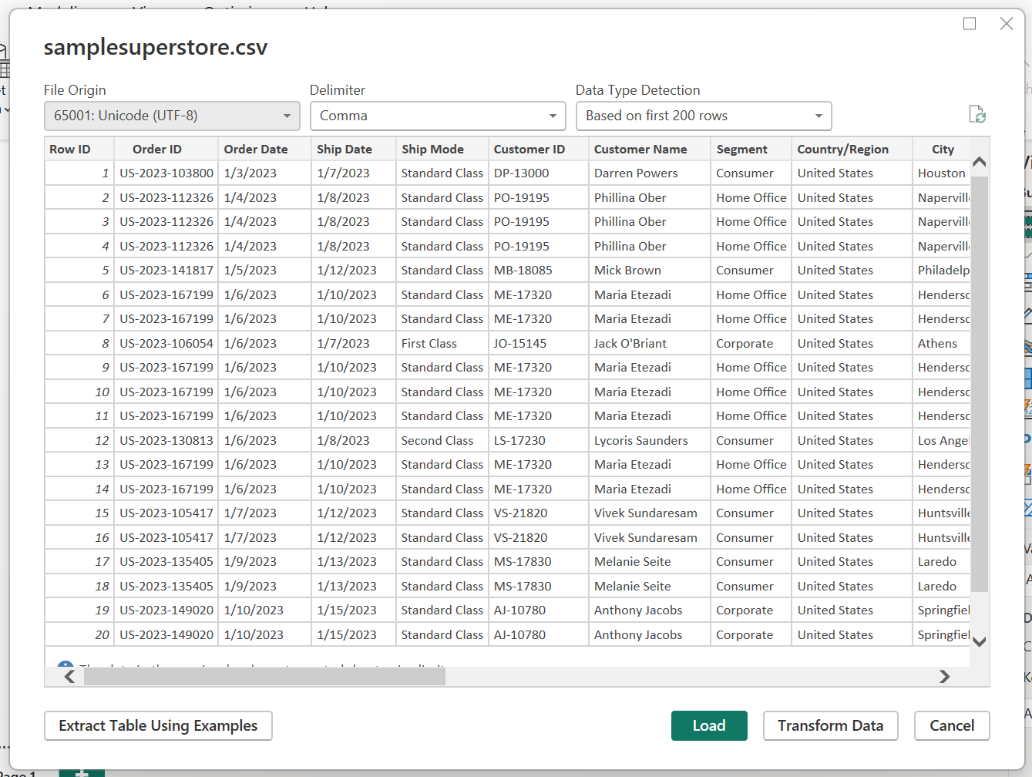

3. Opening Power Query Editor
- The dataset was opened using the Transform Data option.
- Power Query Editor was used to:
  - Inspect columns
  - Check data types
  - Clean text data
  - Transform data
  - Create new columns
- Data quality indicators were checked.
- The dataset showed:
  - 100% Valid
  - 0% Errors
  - 0% Empty values
- This confirmed that the dataset had good data quality before further transformation.
Figure 3: Dataset in Power Query Editor
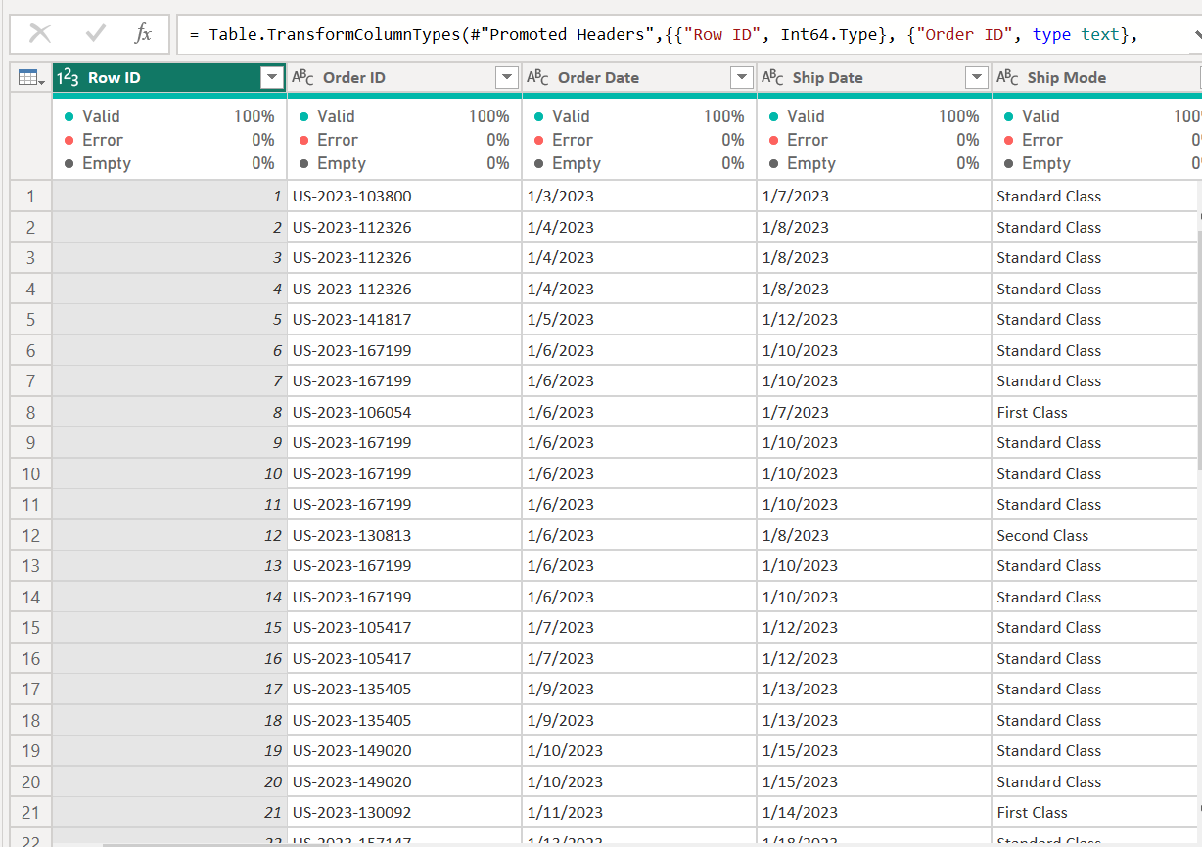

Figure 4: Data Quality Check
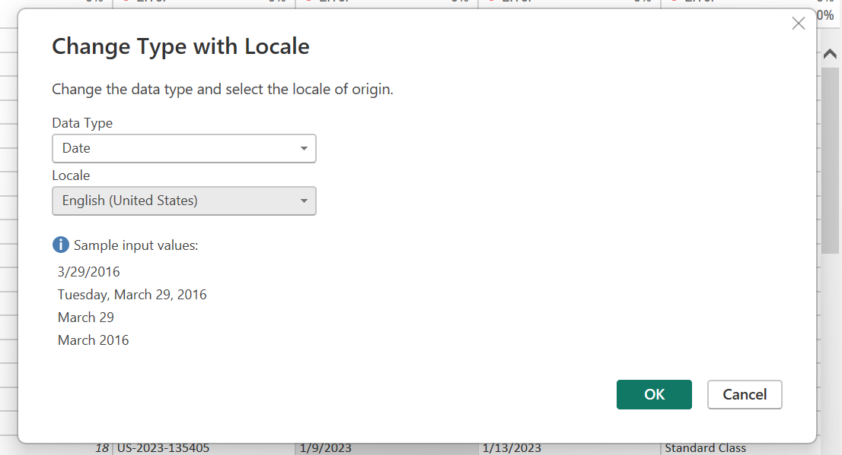

4. Changing Date Data Types
- The Order Date column was initially identified as a Text field.
- The Ship Date column was also identified as a Text field.
- Both columns were converted into the Date data type.
- The Change Type with Locale option was used.
- Data Type was selected as Date.
- Locale was selected as English (United States).
- After conversion:
  - Order Date was recognized as a Date.
  - Ship Date was recognized as a Date.
- This made the date fields suitable for further analysis.
Figure 5: Changing Order Date to Date Type

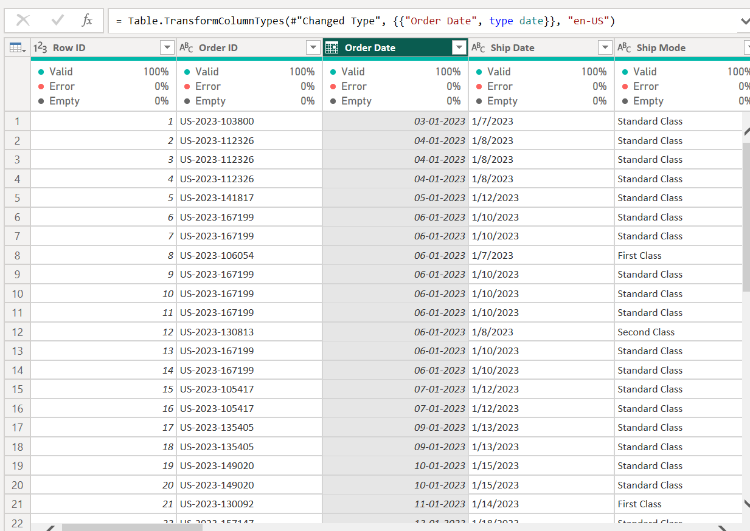
Figure 6: Changing Ship Date to Date Type
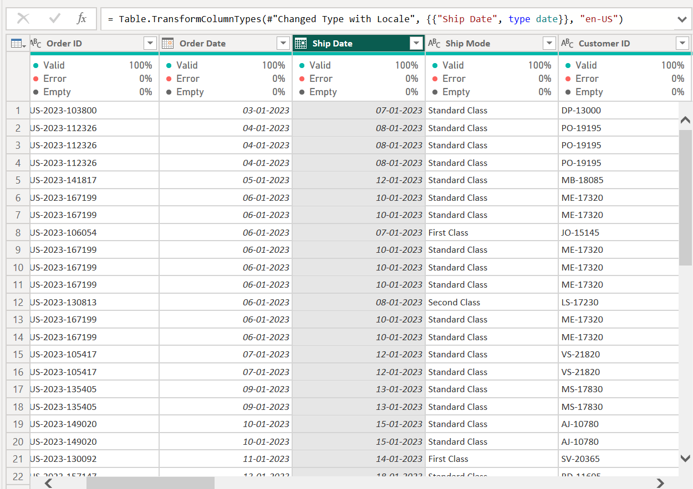
5. Trimming Text Columns
- Text columns were cleaned using the Trim option.
- Trim removes unnecessary spaces from the beginning and end of text values.
- Trim was applied to the following columns:
  - Ship Mode
  - Customer ID
  - Customer Name
  - Segment
  - Country/Region
  - City
  - State
  - Region
  - Product ID
  - Category
  - Sub-Category
  - Product Name
- This helped to:
  - Remove unwanted spaces
  - Maintain consistency
  - Improve data quality
  - Avoid problems during analysis
Figure 6: Applying Trim to Text Columns
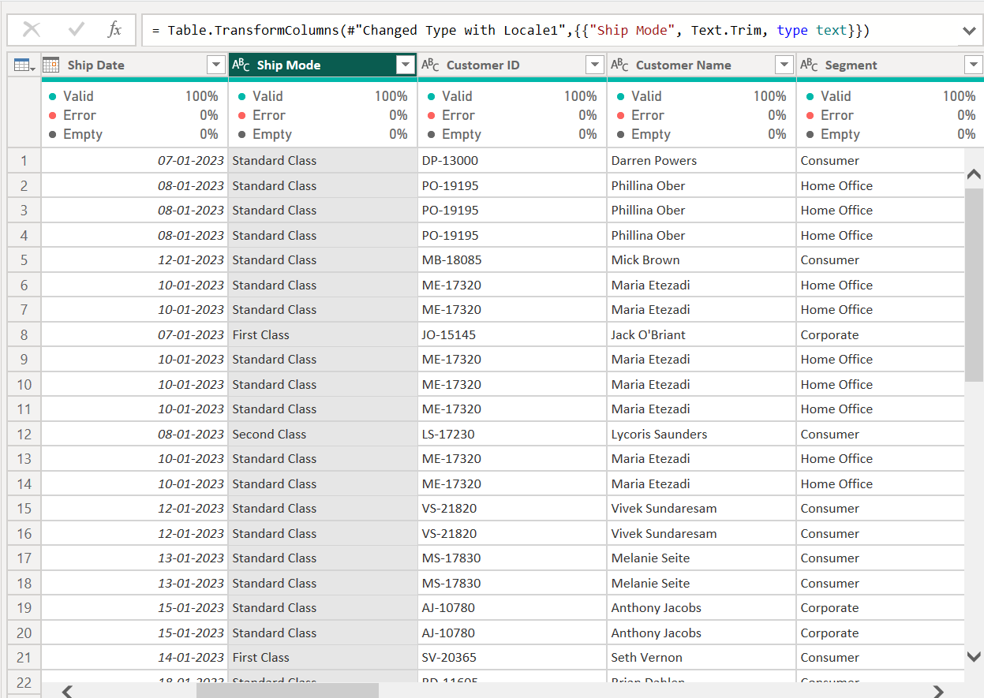

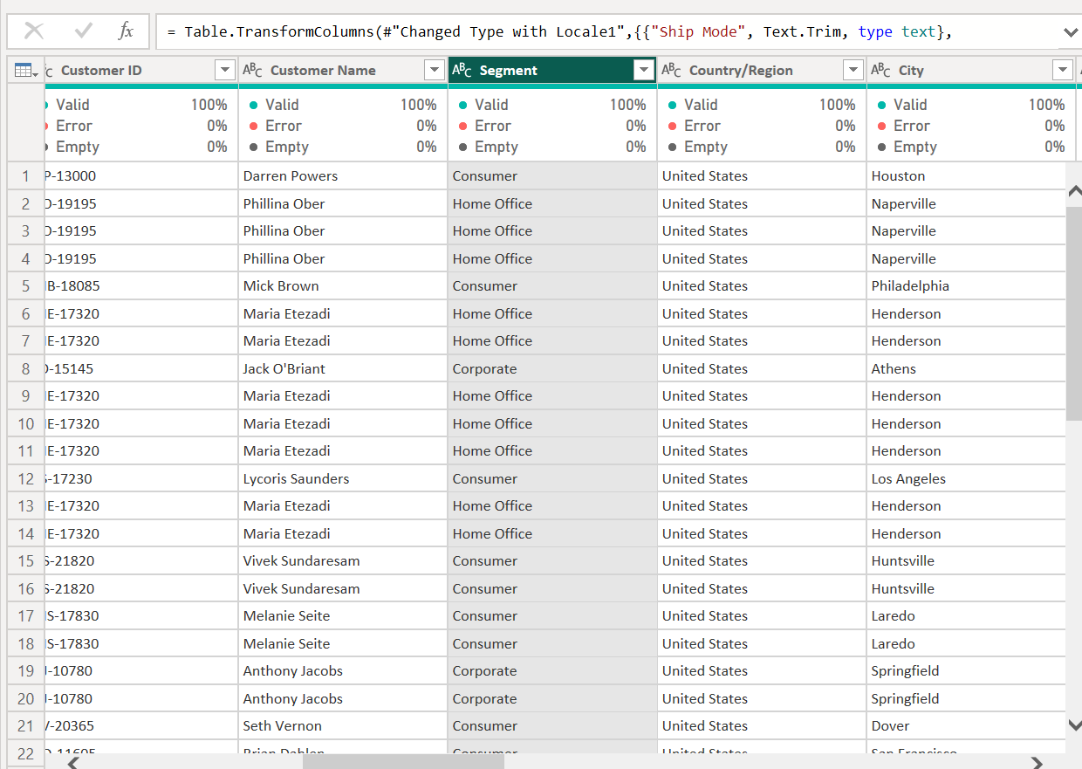
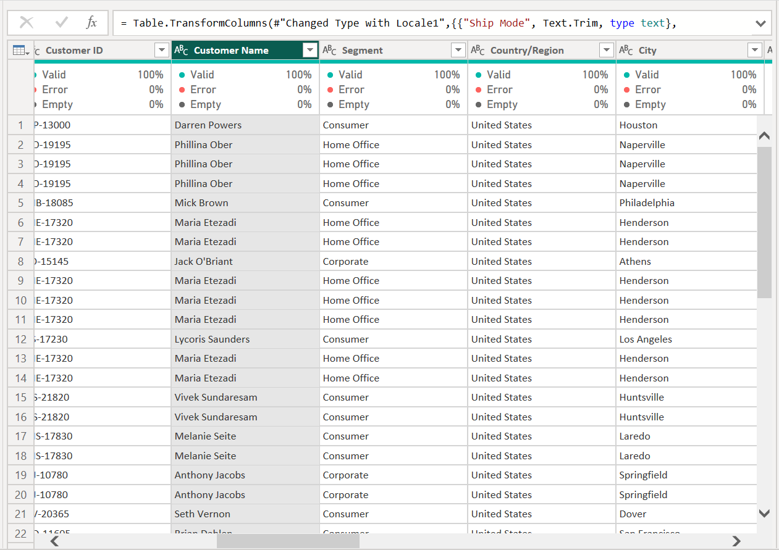

6. Adding a New Column
- A new column was created in Power Query.
- The Add Column option was used.
- A duplicate of the required column was created.
- The new column was used for additional transformation.
- The original column was kept unchanged.
- This helped to preserve the original dataset while performing transformations.
Figure 7: Adding a New Column
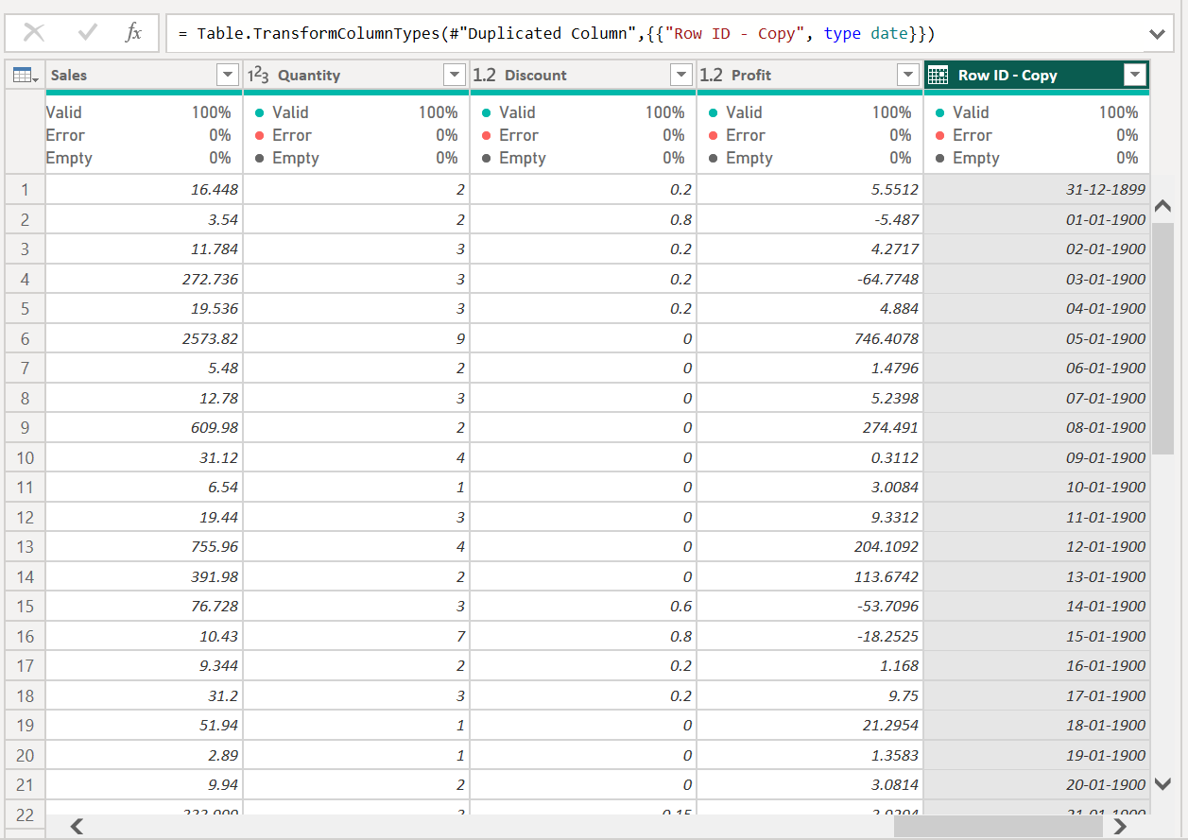

7. Extracting Year from Date
- The date field was further transformed to obtain the Year.
- A separate Year column was created.
- The following option was used:
Add Column → Date → Year → Year
- The Year column contains only the year values.
- The separate Year column can be used for:
  - Year-wise analysis
  - Comparing sales across years
  - Creating charts
  - Creating Power BI visualizations
Figure 8: Extracting Year from Date
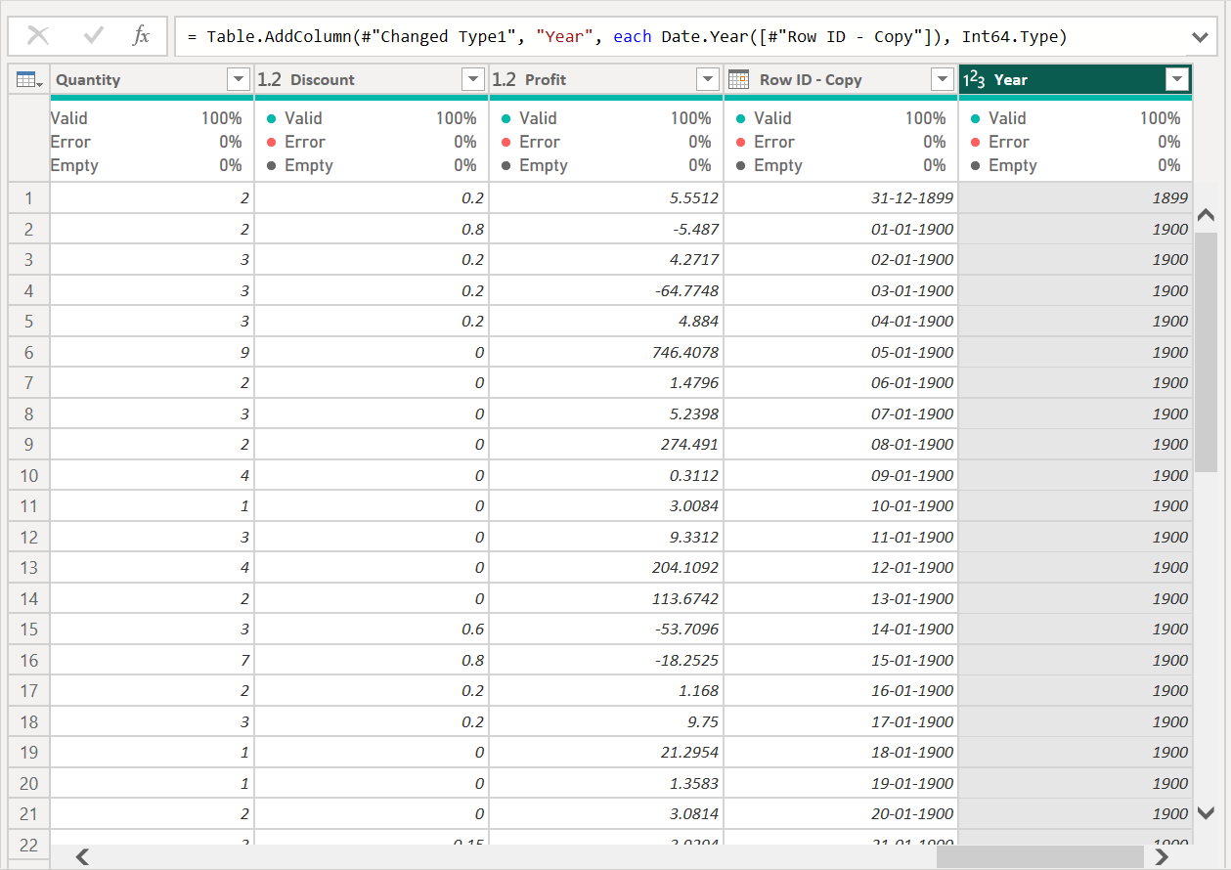

8. Data Quality Check
- The dataset was checked again after completing all transformations.
- The following operations were successfully completed:
  - Date columns converted to Date type
  - Text columns cleaned using Trim
  - New column added
  - Year extracted from the date field
- The transformed data was checked for proper formatting.
- The dataset was prepared for further analysis and visualization.
Figure 9: Final Cleaned Dataset
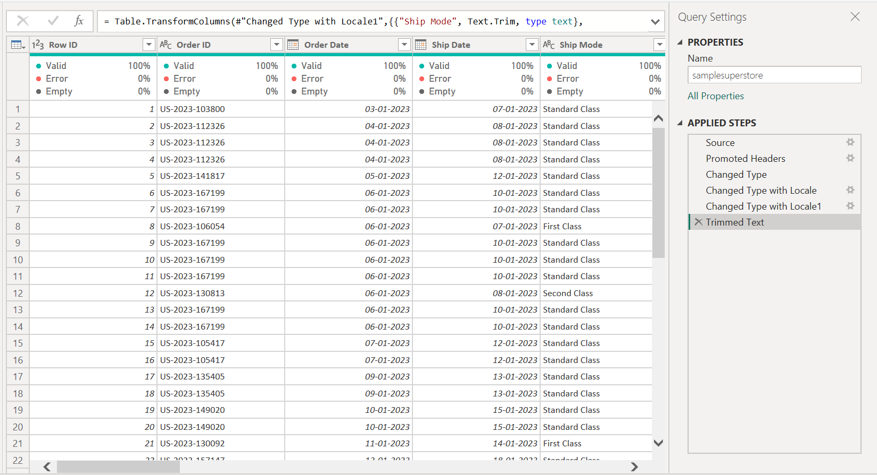

9. Conclusion
- The Superstore Sales dataset was successfully imported into Power BI.
- Power Query Editor was used for data cleaning and transformation.
- The following tasks were completed:
  - Dataset import
  - Date type conversion
  - Text trimming
  - New column creation
  - Year extraction
  - Data quality checking
- The cleaned dataset is now ready for:
  - Data analysis
  - Report creation
  - Charts and visualizations
  - Power BI dashboard development
Final Result: The Superstore Sales dataset was successfully cleaned and transformed using Power Query and is ready for further analysis in Power BI.

